Name Habtamu Fissha

ID:-NSR/1040/05

MEO satellite (medium earth orbit satellite)
Medium Earth orbit (MEO) sometimes called intermediate circular orbit (ICO). A MEO is one with an orbit within the range from a few hundred miles to a few thousand miles above the earth's surface. Satellites of this type orbit higher than low earth orbit (LEO) satellites, but lower than geostationary satellites.
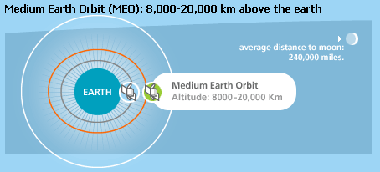
- These orbits are primarily reserved for communications satellites that cover the North and South Pole. 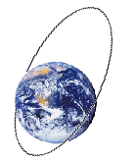

The orbital periods of MEO satellites range from about two to 12 hours. Some MEO satellites orbit in near perfect circles, and therefore have constant altitude and travel at a constant speed. Other MEO satellites revolve in elongated orbits. The perigee (lowest altitude) of an elliptical-orbit satellite is much less than its apogee (greatest altitude). The orbital speed is much greater near perigee than near apogee. As seen from a point on the surface, a satellite in an elongated orbit crosses the sky in just a few minutes when it is near perigee, as compared to several hours when it is near apogee. Elliptical-orbit satellites are easiest to access near apogee, because the earth-based antenna orientation does not have to be changed often, and the satellite is above the horizon for a fairly long time.
A fleet of several MEO satellites, with orbits properly coordinated, can provide global wireless communication coverage. Because MEO satellites are closer to the earth than geostationary satellites, earth-based transmitters with relatively low power and modest-sized antennas can access the system. Because MEO satellites orbit at higher altitudes than LEO satellites, the useful footprint (coverage area on the earth's surface) is greater for each satellite. Thus a global-coverage fleet of MEO satellites can have fewer members than a global-coverage fleet of LEO satellites.
The most common use for satellites in this region is for navigation, communication, and geodetic/space environment science.
Their signal takes from 50 to 150 milliseconds to make the round trip. MEO satellites cover more earth area than LEOs but have a higher latency. MEOS are often used in conjunction with GEO satellite systems.
Telstar, one of the first and most famous experimental satellites, obited in MEO.

_{Advantages:}

_{Disadvantages:}

Reference
http://classes.bus.oregonstate.edu/fall-06/ba479/PowerPoint/Group%20Presentations/BA%20479%20Satellites%20Presentation.ppt
http://iml.jou.ufl.edu/projects/fall99/coffey/meo.htm
http://searchmobilecomputing.techtarget.com/definition/MEO-satellite
http://en.wikipedia.org/wiki/Medium_Earth_orbit
The compiled document is available below
http://habtaxthecomp.weebly.com/uploads/4/3/7/6/43763911/meo_satellite.docx

